Assignment 8 Report

Rong Wan

This assignment is the testing of the previous assignment. The code is mostly unchanged except that I corrected the dependency injection annotations and added necessary build paths. In addition, some earlier errors are fixed such as the duplicate treatments in the patient object.



As previous assignments, the sample data has four patients and three providers with 12 treatments. I used a browser tool RESTer instead of curl for convenience and visualization as you can see in the video.

Below are some screenshots to show the main point of this assignment (Screenshots of some request and a full list of all request with results, which you can also see in videos)

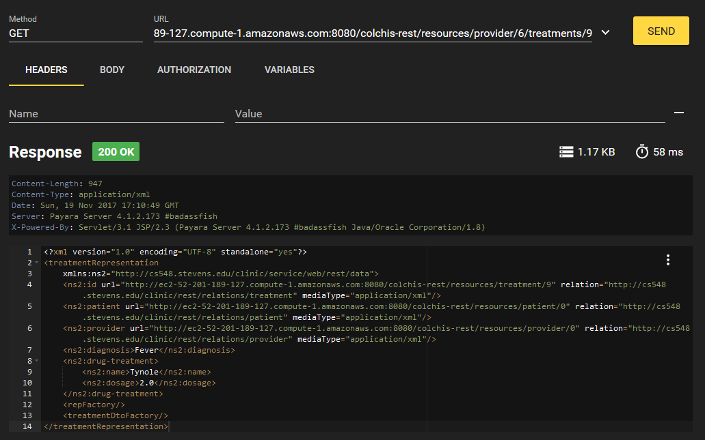

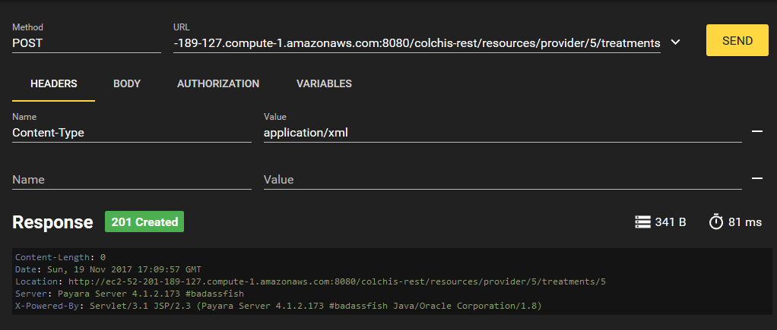

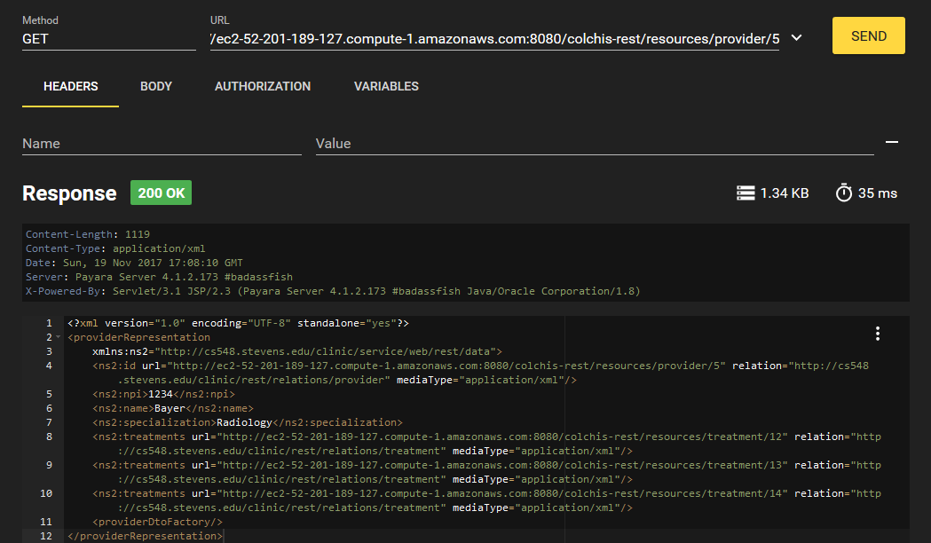

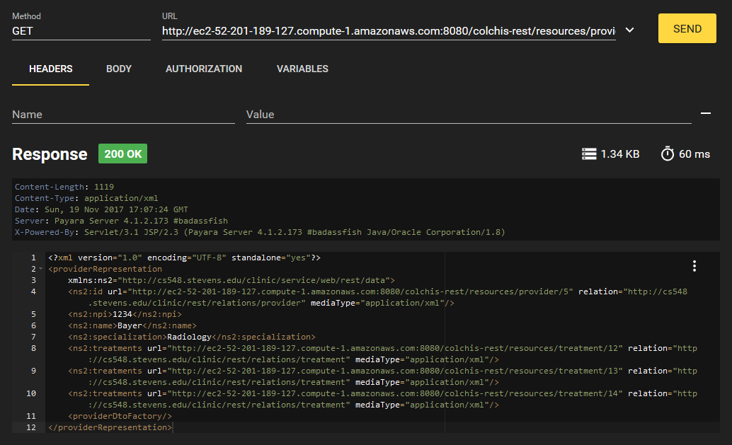

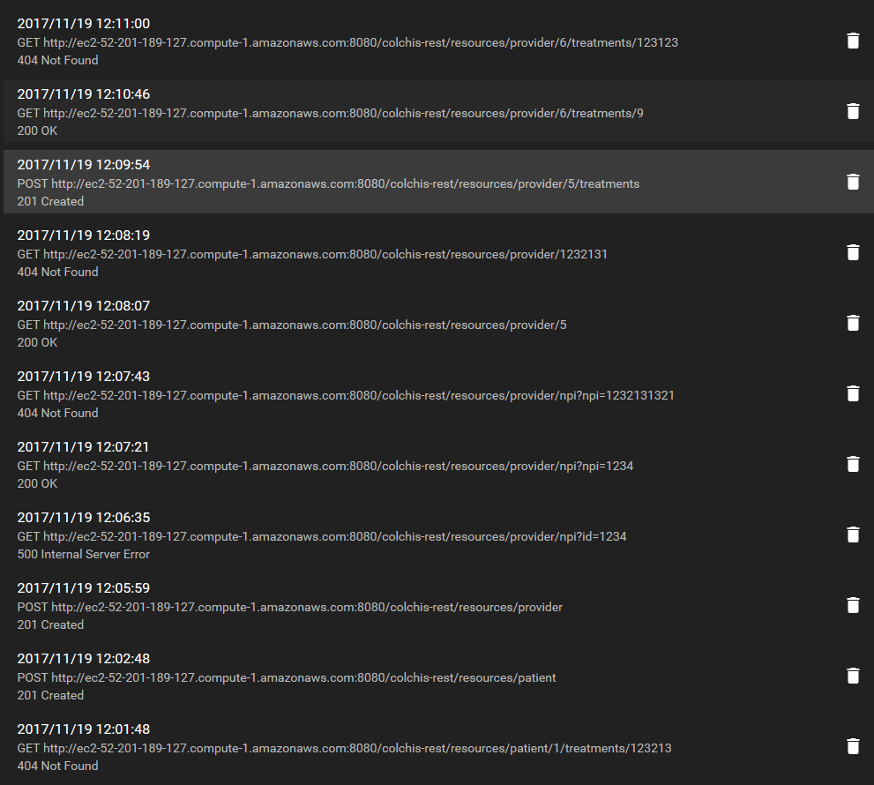

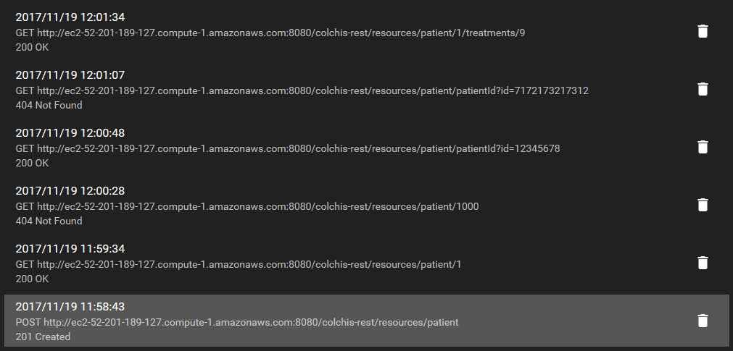

All these requests are recorded and in the videos, and as before the videos may have problem with the Windows 10 player